In-Class Activity Lecture 6

1. The weekly downtime *x* (in hours) for a certain industrial machine has approximately a gamma distribution with *_* = 4 and *_* = 1*.*5. The loss (*l*) to the industrial operation as a result of this downtime is given by *l* = 30*x* + 2.
2. Find the probability that the down time is not more than 2 hours.

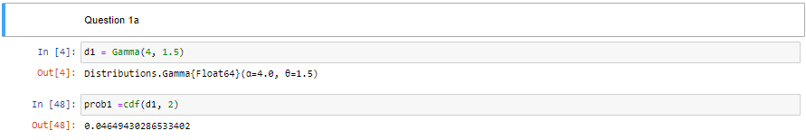

1. Find the expected value and the variance of l

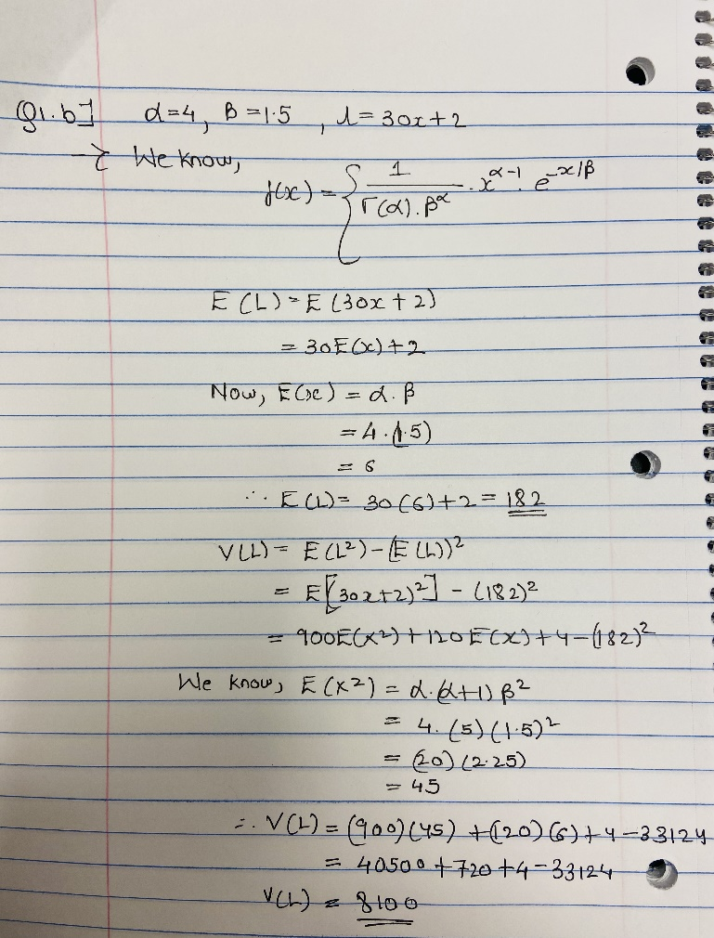

1. The weekly amount spent for maintenance and repairs in a certain company has an approximately normal distribution with a mean of $600 and a standard deviation of $40.
2. If $700 is budgeted to cover repairs for next week, what is the probability that the actual costs will exceed the budgeted amount?

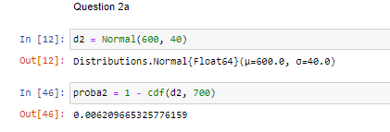

1. How much should be budgeted weekly for maintenance and repairs to ensure that the probability that the budgeted amount will be exceeded in any given week is only 0.1?



1. The proportion of impurities per batch in a certain type of industrial chemical is a random variable x that has a probability density function
2. Suppose that a batch with more than 30% impurities cannot be sold. What is the probability that a randomly selected batch cannot be sold for this reason?

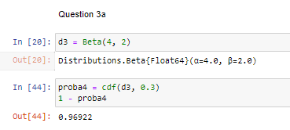

1. Suppose that the dollar value of each batch is given by v = 10 − 0.75x. Find the expected value and variance of v.

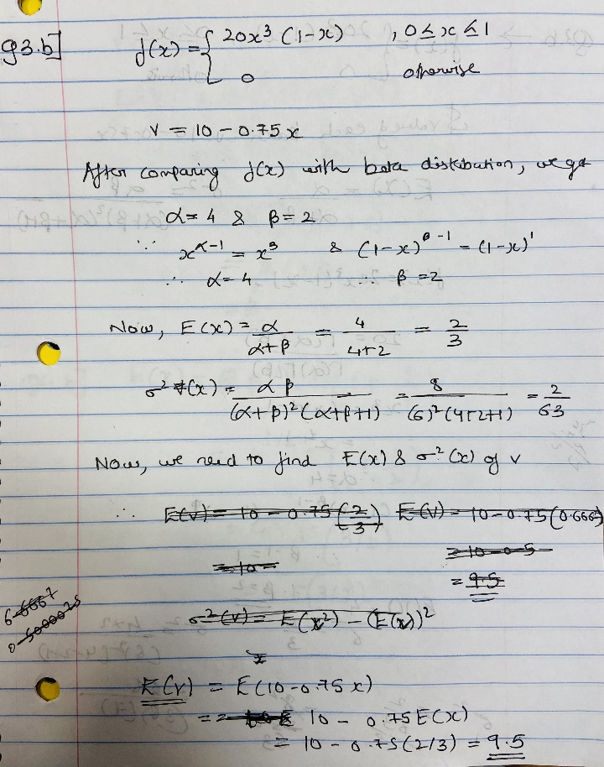

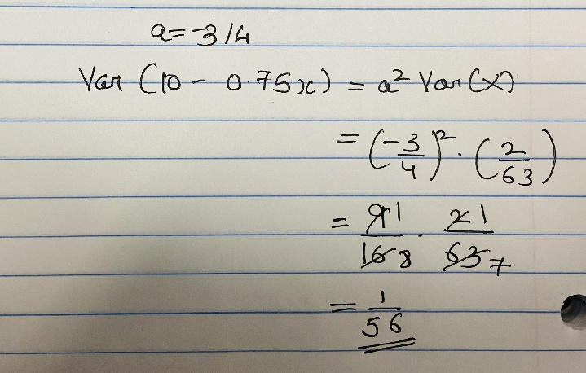

1. Fatigue life (in hundreds of hours) for a certain type of bearing has a Weibull distribution with = 2 and _ = 4.
2. What is the probability that a randomly selected bearing of this type will fail in less than 200 hours?

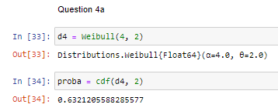

1. What is the expected value of the fatigue life for these bearings? (Leave the 􀀀 function as it is in the final result.

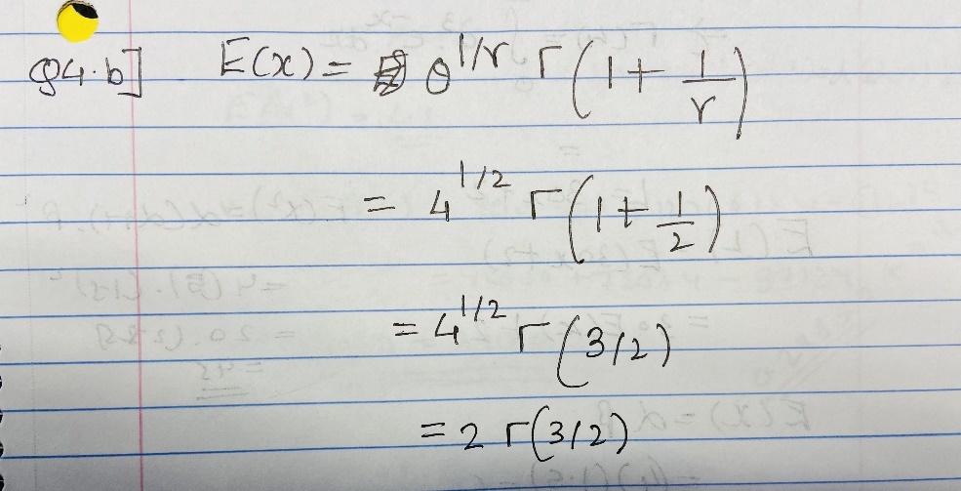

1. Write Julia code to plot pdf of the distributions in the above four questions

Gamma:

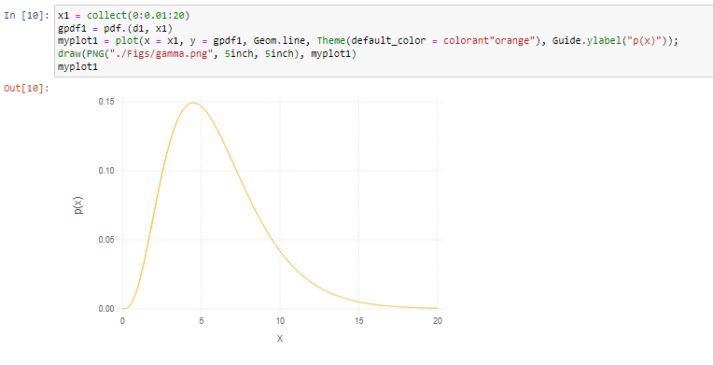

Normal:

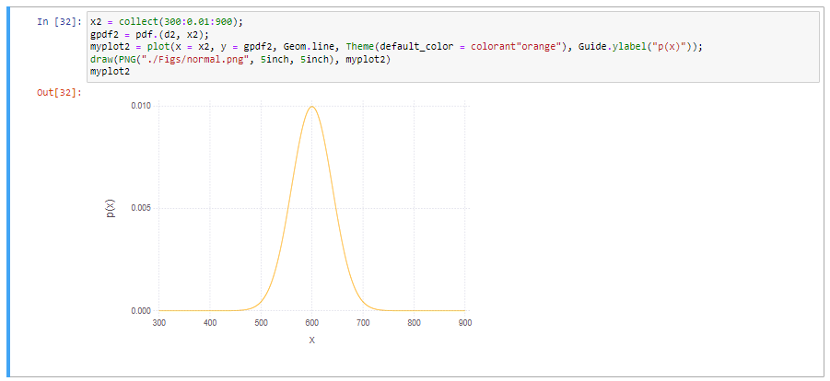

Beta

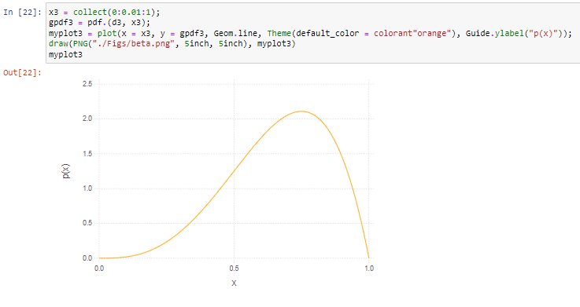

Weibull

